ChannelServer User Guide

Version: 1.0.4
DocCode: SW -BASE-UG -0003
Date: Mar 13, 2014


www.spreadtrum.com
Important Notice
Copyright Notice
Copyright © 2007-2011, Spreadtrum Communications, Inc. All rights reserved.
Trademarks
Spreadtrum Communications, Inc. and Spreadtrum Communications, Inc.'s products are exclusively owned by Spreadtrum Communications, Inc. References to other companies and their products use trademarks owned by the respective companies and are for reference purpose only.
Warranty Disclaimer
Spreadtrum Communications, Inc. makes no representations or warranties, either expressed or implied, by or with respect to anything in this document, and shall not be liable for any implied warranties of merchantability or fitness for a particular purpose or for any indirect, special or consequential damages.
Confidentiality
The information contained herein (including any attachments) is confidential. The recipient hereby acknowledges the confidentiality of this document, and except for specific purposes, this document shall not be disclosed to any third party.
About This Document

Purpose
The ChannelServer User Guide describes the functions and how to use ChannelServer.

Intended Audience
This document is intended for:
- Production test engineer

Organization
This document consists of two chapters and is organized as follows.
Chapter | Describes
1 Introduction | The functions, file composition, and running requirements of ChannelServer.
2 Operation Guide | How to use ChannelServer.

Contents
1 Introduction 1-1
1.1 Functions 1-1
1.2 File Composition 1-1
1.3 Running Requirements 1-2
2 Operation Guide 2-3
2.1 Icon 2-3
2.2 Menu 2-3
2.3 Configure 2-4
2.3.1 Configure Tab Page 2-4
2.3.2 Client_Info Tab Page 2-7
2.4 Icons 2-7
2.5 About 2-8
2.6 Exit 2-8
2.7 Running Multiple ChannelServers at the Same Time 2-8

Figures
Figure 2-1 ChannelServer icon 2-3
Figure 2-2 ChannelServer menu 2-3
Figure 2-3 Channel Server Configure dialog box 2-4
Figure 2-4 Client_Info tab page 2-6
Figure 2-5 Connect MSSim and Disconnect MSSim menu items 2-7
Figure 2-6 Version information 2-9

Tables
Table 2-1 ChannelServer menu items 2-3
Table 2-2 Channel Server parameters 2-5
Table 2-3 MS parameters 2-5

Introduction

Functions
ChannelServer connects to other tools through Socket and to the mobile through a serial port. It performs the following functions:
- Data saving and forwarding
ChannelServer saves the messages from other tools in the message queue and sends the messages to the MSSim or MS in sequence.
- Message recording
According to the message transfer direction, ChannelServer saves all the messages in the following files:
Request.log: All request and response messages, text format
MS_To_CS.bin: All log and trace data from ms to ChannelServer, binary version
CS_To_Tool.bin: All log and trace data from from ChannelServer to tools, binary version

File Composition
ChannelServer consists of the following files:
- ChannelServer.exe
- DiagChan.dll
- Channel.dll
- Channel.ini
- DiagChan.ini
- ChannelServer.ini
- CrashReport.dll
Before running ChannelServer, ensure that all the files are in the same directory.

Running Requirements
ChannelServer runs on Windows 2000. At least one usable serial port and one network card is required.

Operation Guide

Icon
The green icon shown in Figure 2-1 is ChannelServer.
              - ChannelServer icon

Menu
Right-click the icon. The shortcut menu is displayed, as shown in Figure 2-1.
              - ChannelServer menu
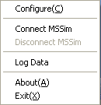

                - ChannelServer menu items
Menu Item | Description
Configure | Configure parameters
Connect MSSim | Connect to MS/MSSim
Disconnect MSSim | Disconnect from MS/MSSim
Log Data | Record all data
About | Display software version
Exit | Exit

Configure

Configure Tab Page
Click Configure. The Channel Server Configure dialog box is displayed, as shown in Figure 2-1.
              - Channel Server Configure dialog box
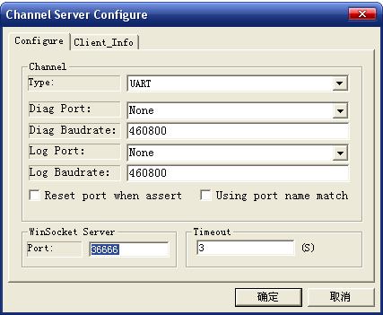

Note:
You can also click the icon to display the Channel Server Configure dialog box.

UART Connect Parameters
                - MS parameters
Parameter | Description
Type | UART: when connected to the mobile
Diag Port | Serial port number through DIAG protocol.  Channelserver will list all available UART ports, You can choose one from the list of the combobox. If for some reason Channelserver cannot list the ports, user must input the port number in the edit box.
Diag Baudrate | Diag port baudrate
Log Port | Serial port number through SMP protocol.  Channelserver will list all available UART ports, You can choose one from the list of the combobox. If for some reason Channelserver cannot list the ports, user must input the port number in the edit box.
Log Baudrate | Log port baudrate
Reset port when assert | Reset port when device is assert.
Using port name match | Default is port number to match device.

WinSocket Connect Parameters
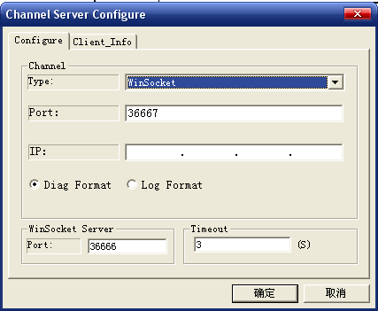
                - MS parameters
Parameter | Description
Type | WinSocket: when connected to MSSim
Port | Port number
IP | - 127.0.0.1: when ChannelServer and MSSim run on the same PC  - MSSim host address: when ChannelServer and MSSim run on different PCs

Channel Server Parameters
                - Channel Server parameters
Parameter | Description
Port | 5050 or above

Timeout
This parameter describes the saving period of a message in a message queue. Upon timeout, if the message is not processed or still has no result returned, ChannelServer sends a timeout message to the sender and deletes the message.

Client_Info Tab Page
Click Client_Info. The information about the tool connected to ChannelServer is displayed, as shown in Figure 2-1.
              - Client_Info tab page
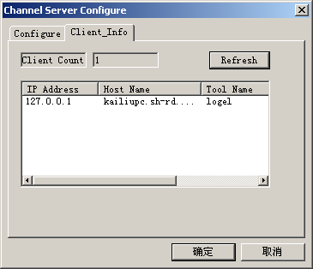

The IP Address column lists the IP addresses of the host PCs. The Host Name column lists the PC names.

Icons
The icons in status bars shows the state of ChannelServer：
ChannelServer is disconnected with MS/MSSim.
ChannelServer is connected with MS/MSSim
ChannelServer is sending data to MS/MSSim.
ChannelServer is receiving data from MS/MSSim.
ChannelServer is sending and receiving data.
ChannelServer received the assert information from MS/MSSim.

About
Select the About item. The version information is displayed, as shown in Figure 2-16.
              - Version information


Exit
To exit ChannelServer, select the Exit menu item or press X.

Running Multiple ChannelServers at the Same Time
Multiple ChannelServers can run at the same time on a PC.
If all the ChannelServers use the default configuration, they may be unable to communicate with other tools or mobile. Therefore, modify the configuration file before running the second ChannelServer or change the parameters on the Configure tab page after running the second ChannelServer. Pay attention that the parameters in the Channel Server and the MS areas may all need to be changed.

